

**APPLIED PHYSICS LAB**

**Lab Report: Verifying Ohm’s Law**

**Submitted To:**

Sir. Haseen Ullah Jan

**Submitted By:**

Section

Registration No.

Department Of Computer Systems Engineering

Fall 2021

**VERIFYING OHM’S LAW**

Ohm’s law is the fundamental law of electricity. Ohm's law states that the current I through a conductor is proportional to the voltage V across its ends. It is written as V=IR, where R is the resistance of the conductor.

**APPARATUS:**

1. D.C. Voltage source.
2. Transformer.
3. Connecting Wires
4. High Resistance Box (H.R.B)
5. Voltmeter
6. Ammeter.

**DIAGRAM:**

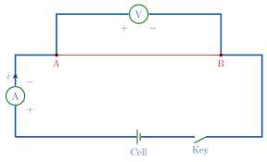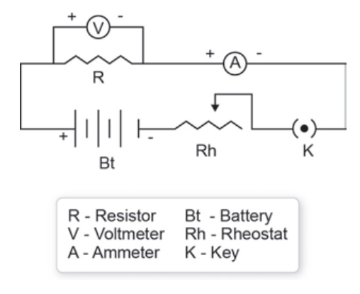

**PROCEDURE:**

* 1. Firstly, I did the connection as shown in the ﬁgure.
  2. Then I put some resistance in the circuit by the help of H.R.B.
  3. With applied resistance from H.R.B, I changed given voltage and note down the current reading.

1. In the second step, I kept voltage constant and change resistance values to get equivalent current valu

**READINGS:**

When Resistance is kept constant.

|  |  |  |  |
| --- | --- | --- | --- |
| S.No | V | I | $$R=\frac{V}{I}$$ |
| 1 | 3.5 v | 50.2 mA | (3.5/0.0503)=67.31 |
| 2 | 4 v | 60 mA | (4/0.060)=66.67 |
| 3 | 1.5 v | 22 mA | (1.5/0.022)=68.1818 |
| 4 | 2 v | 30 mA | (2/0.030)=66.67 |

When Voltage is kept constant.

|  |  |  |  |
| --- | --- | --- | --- |
| S.No | I | R | $$V=IR$$ |
| 1 | 0.5 mA | 1000 | (0.5 mA*1000)=1 V |
| 2 | 0.4 mA | 2500 | (0.4mA*2500)=1 V |
| 3 | 0.3 mA | 3000 | (0.3mA*3000)=0.9 V |
| 4 | 0.2 mA | 3800 | (0.2mA*3800)=0.7 V |

**Precautions:**

1. The connections should be neat and clean.
2. Wire ends should be cleaned with sandpaper.
3. Shunt the ammeter to prevent from damage.